**CM2113 Design Document**

**Thomas Austin -2310336**

**Contents:**

Mood Board 1

Project Plan 2

Level Map 2

List of scanned objects/areas 3

Bipedal character models 5

Details of mechanics 7

Functional requirements 7

Non-functional requirements 7

References 8

**Mood board:**

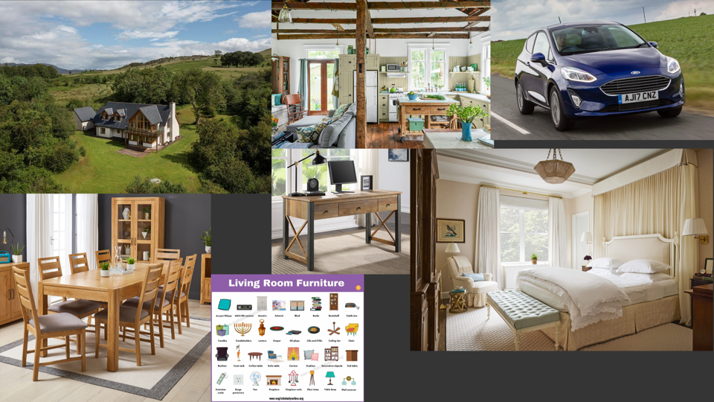

**Project Plan:**

|  |  |  |
| --- | --- | --- |
| Date: | Progress/Tasks: | Stage |
| Week 1 | Mood board and project plan | Design |
| Week 3 | Bipedal characters and some objects scanned and modified in blender.  Level map brainstorm | Implementation and Design |
| Week 5 | Final bipedal scans done | Design |
| Week 7 | Scans of Main rooms (dining room and living room) | Design |
| Week 8 | More objects scanned and modified | Implementation |
| Week 9 | Rigging of Bipedal characters. | Implementation |
| Week 12 | Added assets from unity store, rigged additional bipedal characters. | Implementation |
| Final week | Final implementation of mechanics and meshes.  Design document completed  Testing document completed  Coursework submitted. | Implementation |

**Level Map:**

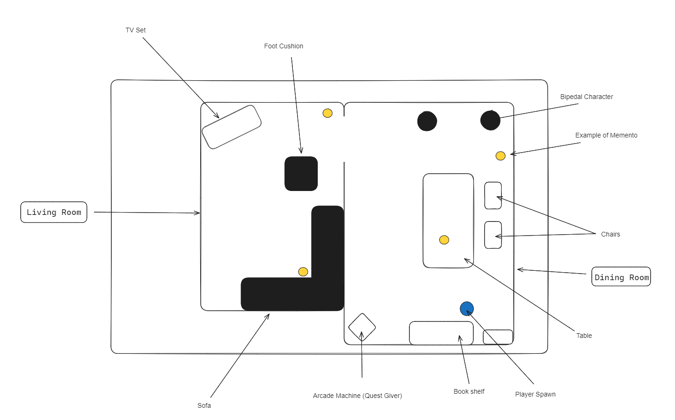

**List of Scanned Objects/Areas:**

Dining Room:

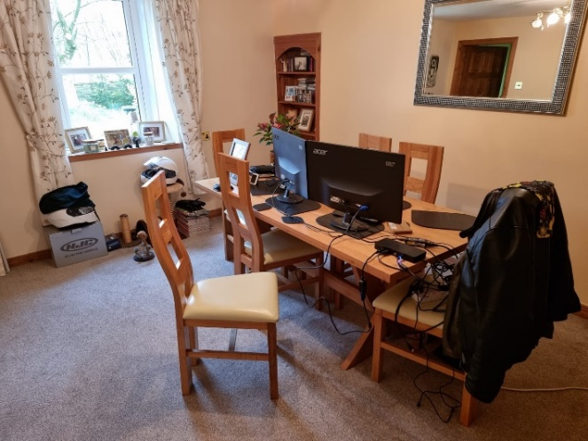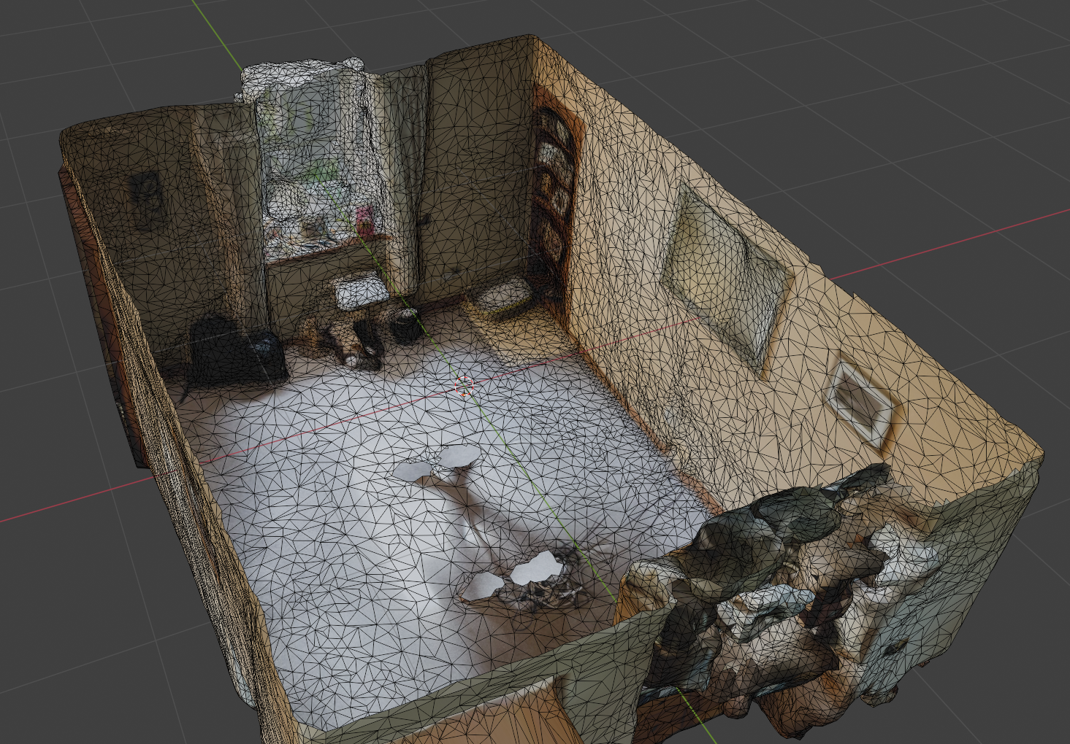

Living Room:

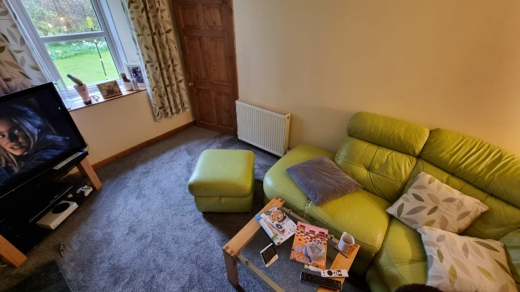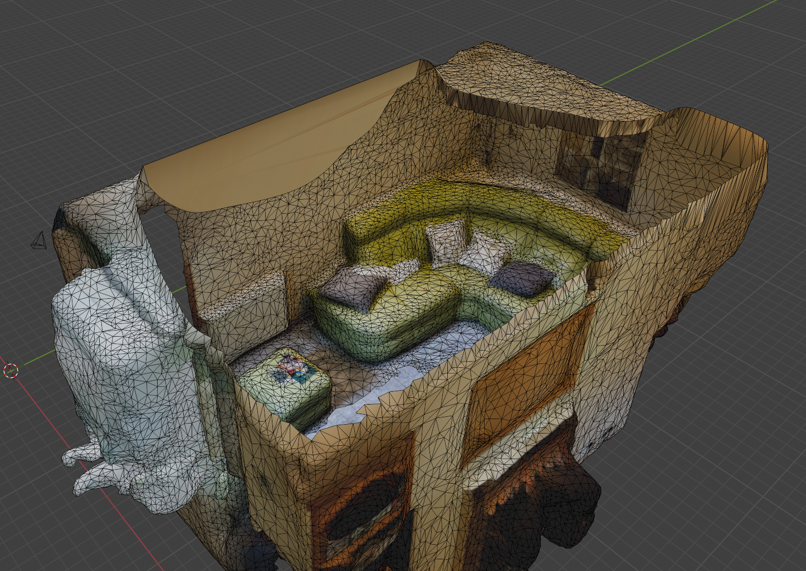

Riven Plushie:

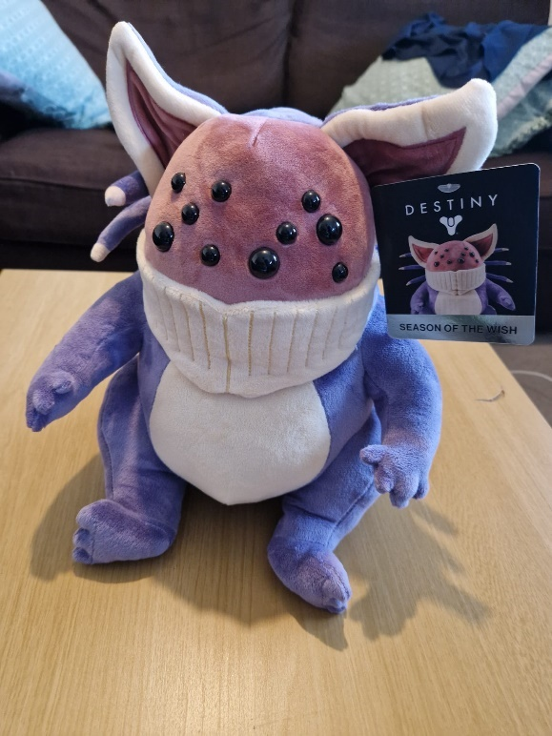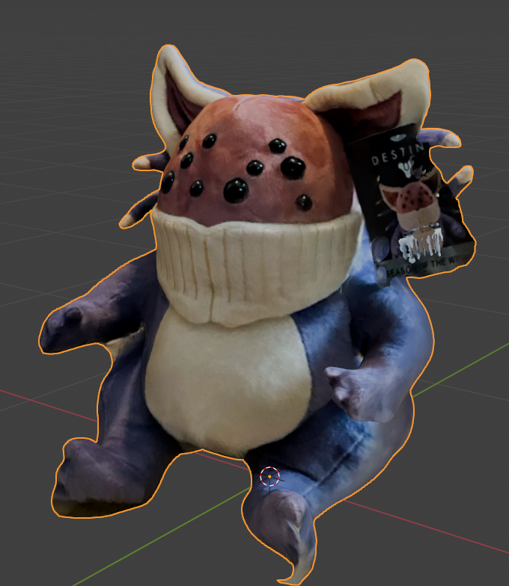

Arcade machine:

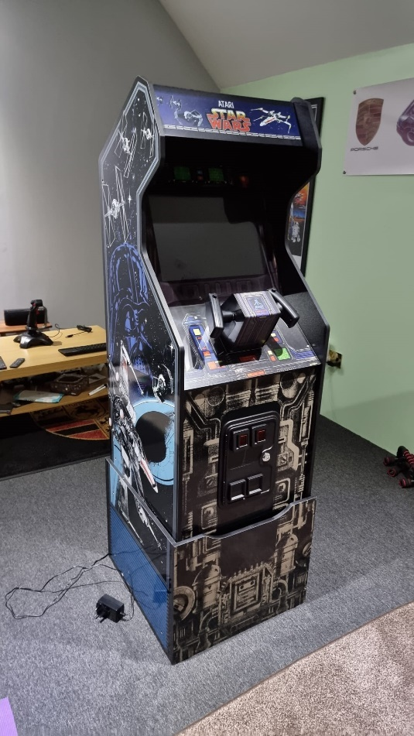 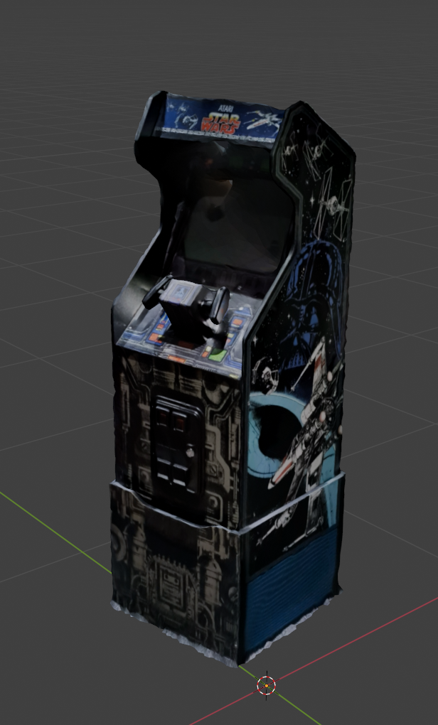

Chair:

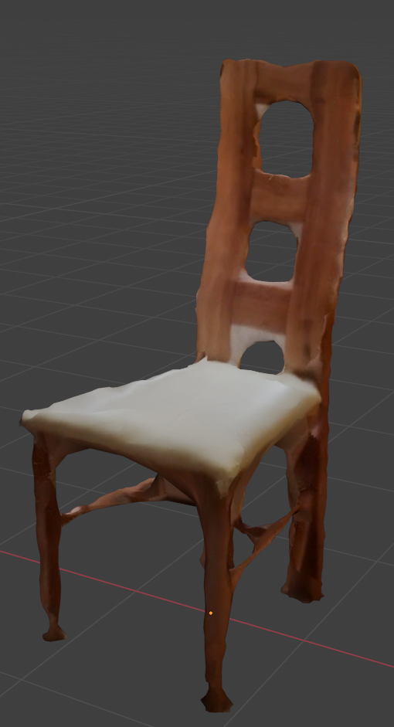 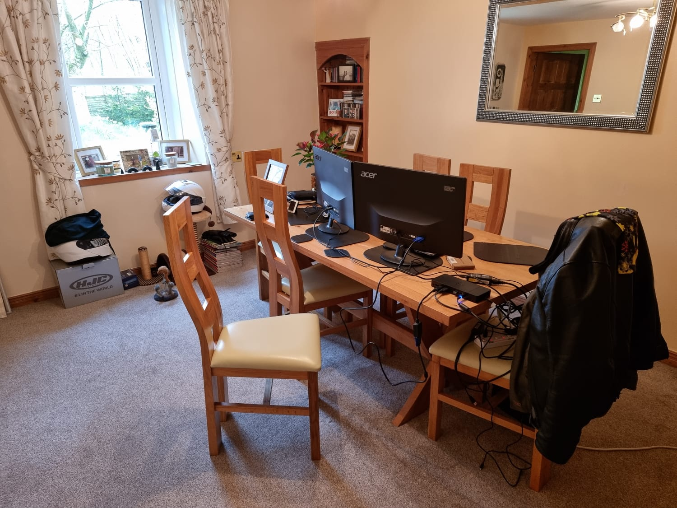

Motorbike:

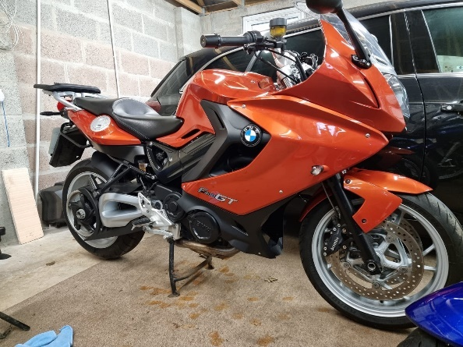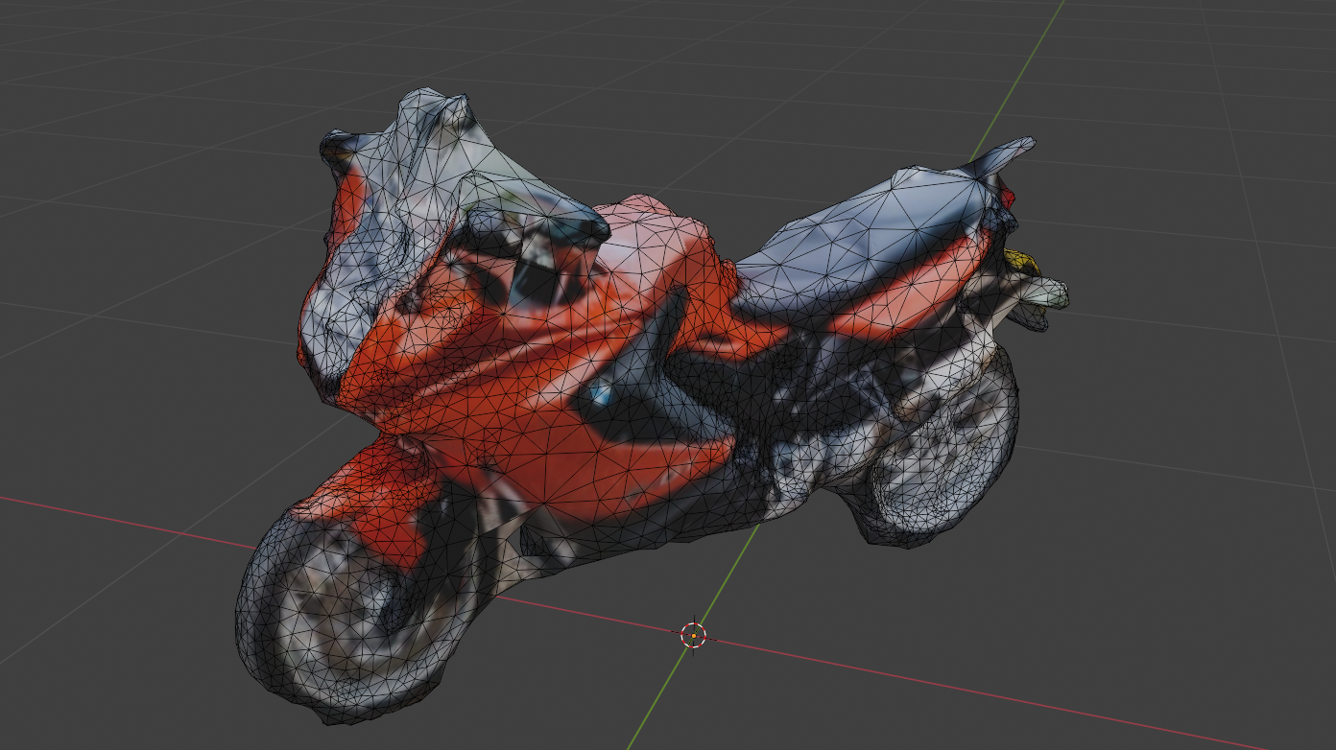

**Bipedal Character models:**

Myself:

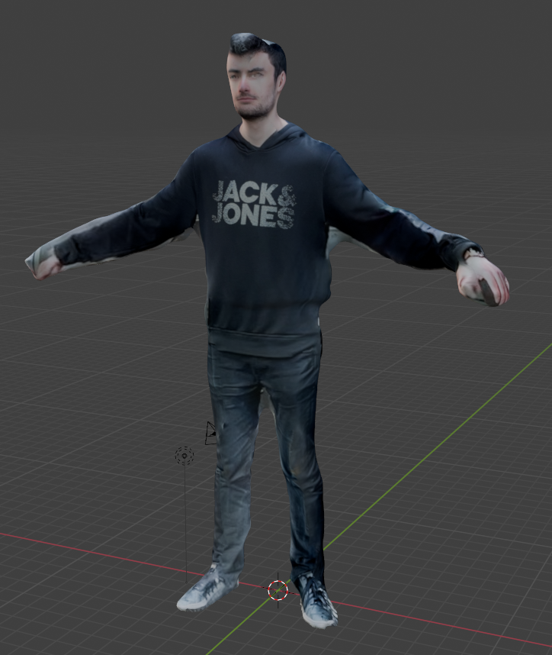

Alex:

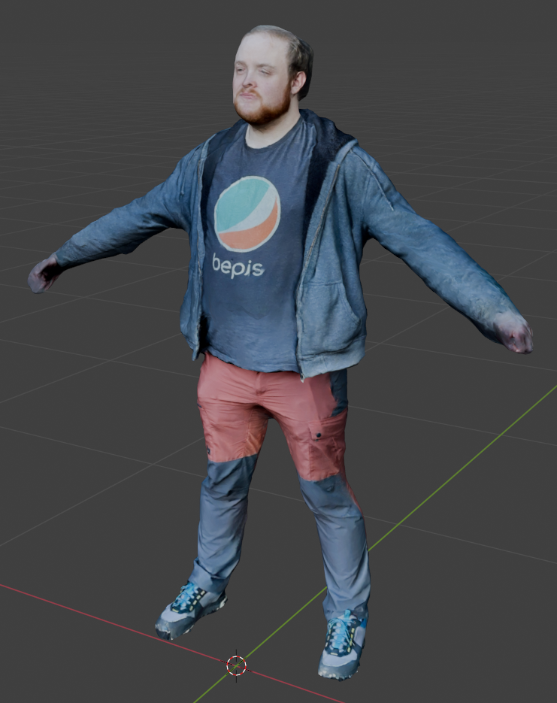

Birnie:

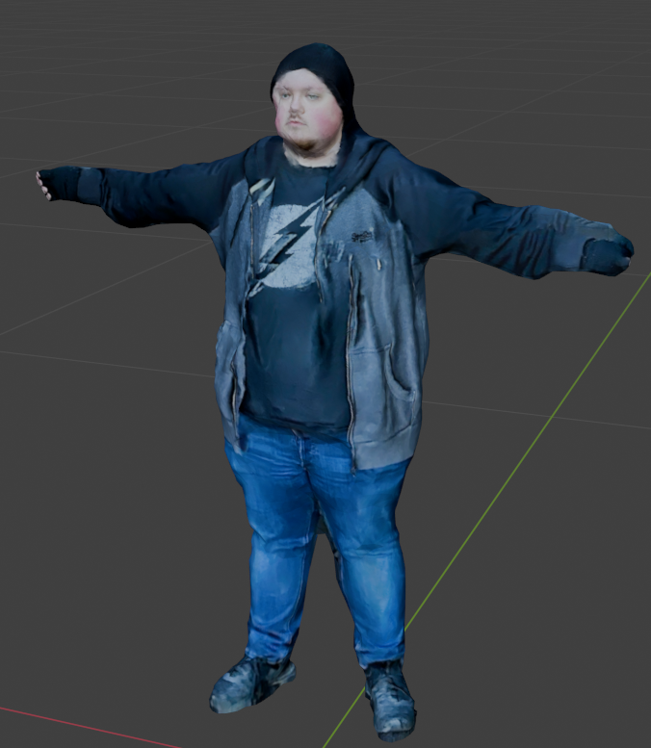

**Details of Mechanics:**

With the idea of wanting to create an interactive walkthrough, the game will need to include good quality photogrammetry scans of the rooms and objects included in the level. For the level itself, I wanted to do a scan of my parent’s house as we thought it would be a fun idea to have a 3d model of our dining room and living room, so naturally I decided to make the game include these environments. Because of this, most of the objects scanned are also from the house i.e. the table, chairs, the arcade machine and a few others.

The mechanics in my game will include a pickup system where the player has to collect all of the hidden items in the game. Each item will be placed around the map and the player will need to plan out how to collect them all.

I will also include some bipedal characters (with permission) with animations within the level as I wanted to include some examples of animations within the project. These characters won’t serve any purpose other than aesthetic.

**Functional Requirements**

For the first requirement, the player will need to be able to move around the environment without any issues i.e. falling through the floor/phasing through walls. The player will also need to be able to appropriately interact with other elements around the map such as being able to stand on the objects around the map like the chairs, this is done through the capsule collider and the mesh collider components. The mobility the character will be able to experience includes walking, running and jumping.

Another functional requirement includes the players ability to pick up mementos (Riven plushie) and increasing the pickup count by one each time.

Additionally, there will be a dialogue trigger for the player to interact with giving the player the objective for the game.

**Non-Functional Requirements**

A clear UI is the first Non-functional requirement that I will implement. This will affect the players interaction with the dialogue object. For this, I will make sure that the font for the text is readable and the size is large enough. I will also make sure that the text presented makes sense to the user.

Another non-functional requirement includes making the particle system present without obstructing any relevant game features in the level. This will be done with putting in a suitable location and adjusting the size/brightness accordingly.

Another requirement could include music being added to the game while the user plays. This music would be background music to break the silence in game and make the experience more enjoyable. Additionally I could also add sound effects to the game for triggers such as picking up the mementos.

**References**

Mixamo Animations:

-Swinging dance

-Gangnam Style

Unity packages:

<https://assetstore.unity.com/packages/tools/utilities/dialogue-editor-168329> - Dialogue Editor by Grasshop Dev

<https://assetstore.unity.com/packages/templates/systems/3rd-person-controller-fly-mode-28647> - 3rd Person Controller + fly Mode by Vinicius Marques

Particle effects image –

<https://www.filterforge.com/filters/11713-v3.html>